Maynard N. Basa BSIT301

I create this kind of design for my interface in order to emphasize the HCI principles of Designing which is:

1. Reduce memory load

- The design of my website focuses on using as little possible amount of words in order to not make it too complicated for the user while also giving them the necessary information that they need without boring them.

2. Know the user

- The design target users are for players of League of Legends which is mostly made up of teenagers or adults, so I made the design into something that is sulted to the style of modern games while also applying different colors to appeal to a younger audience.

3. Srtive the Consistency

- The design also has consistent placement of the different buttons and pictures that link to other parts of the website, the design's positioning of those parts are consistently put together or are grouped accodingly and is not scattered around the website in order to avoid confusion or unnecessary searching.

4. Understand the Task

- The design of this interface also emphasizes the purpose of the vistors, which is to know the things that is going on with the game; news, updates, trends and others. The interface also does this minimistically with the use of pictures and simple one word labels which takes them to a more detailed page that the button or link was meant to do with the content it's showing in the main page.

5. Remind the users, Prevent errors/Reversal of Action

- These two principlesare grouped together when it comes to applying the principles, the website doesn't really necessarily have to remind the users when it comes to confirmation, except when it comes to Login processes and sign up confirmations or other errors when you login and sign-up to get a news for the game.

HOMEPAGE

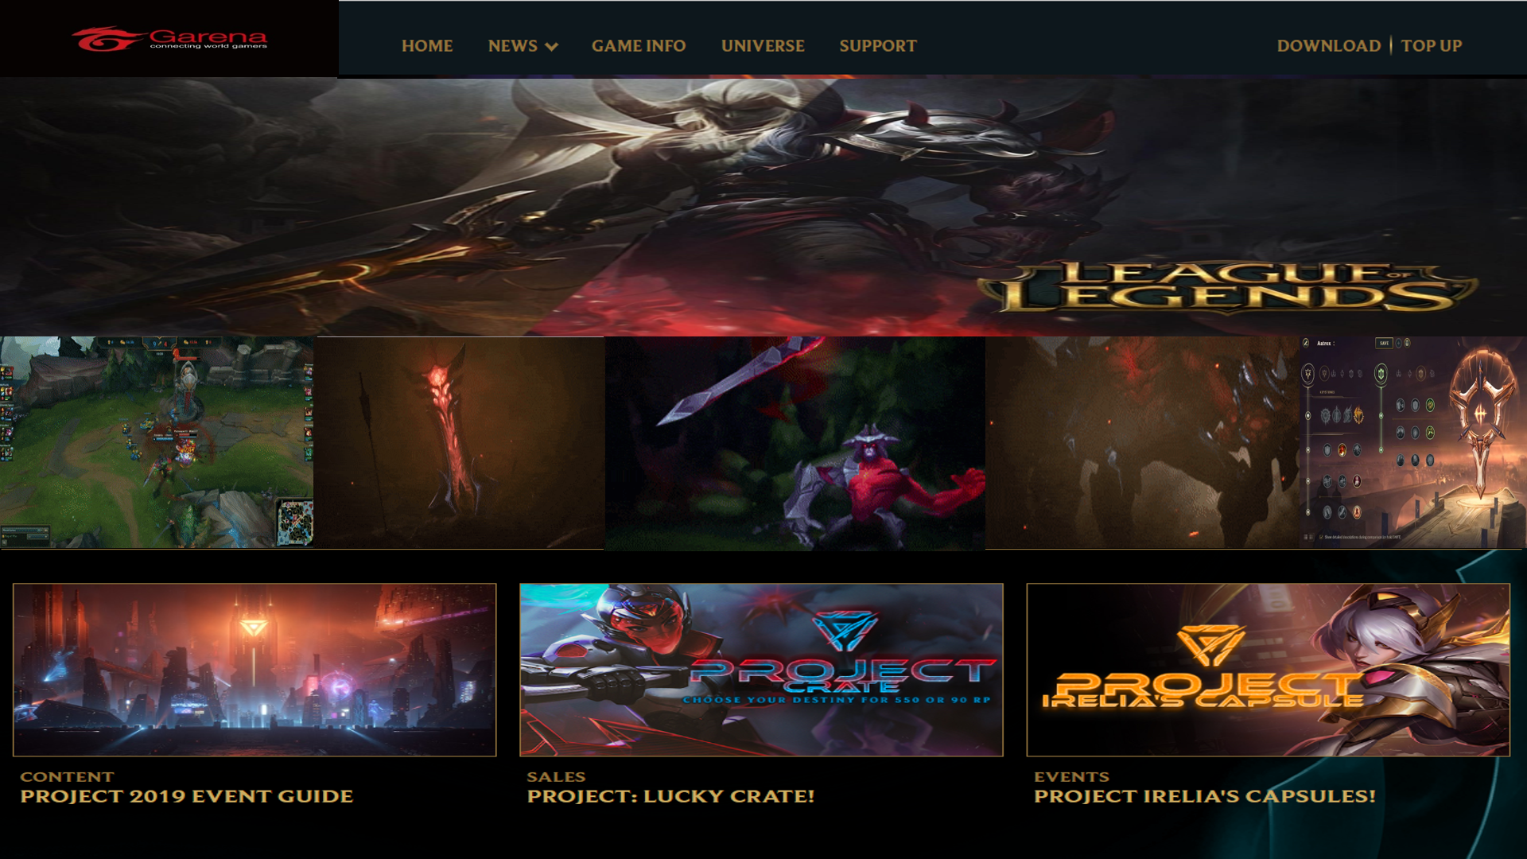

LOGIN 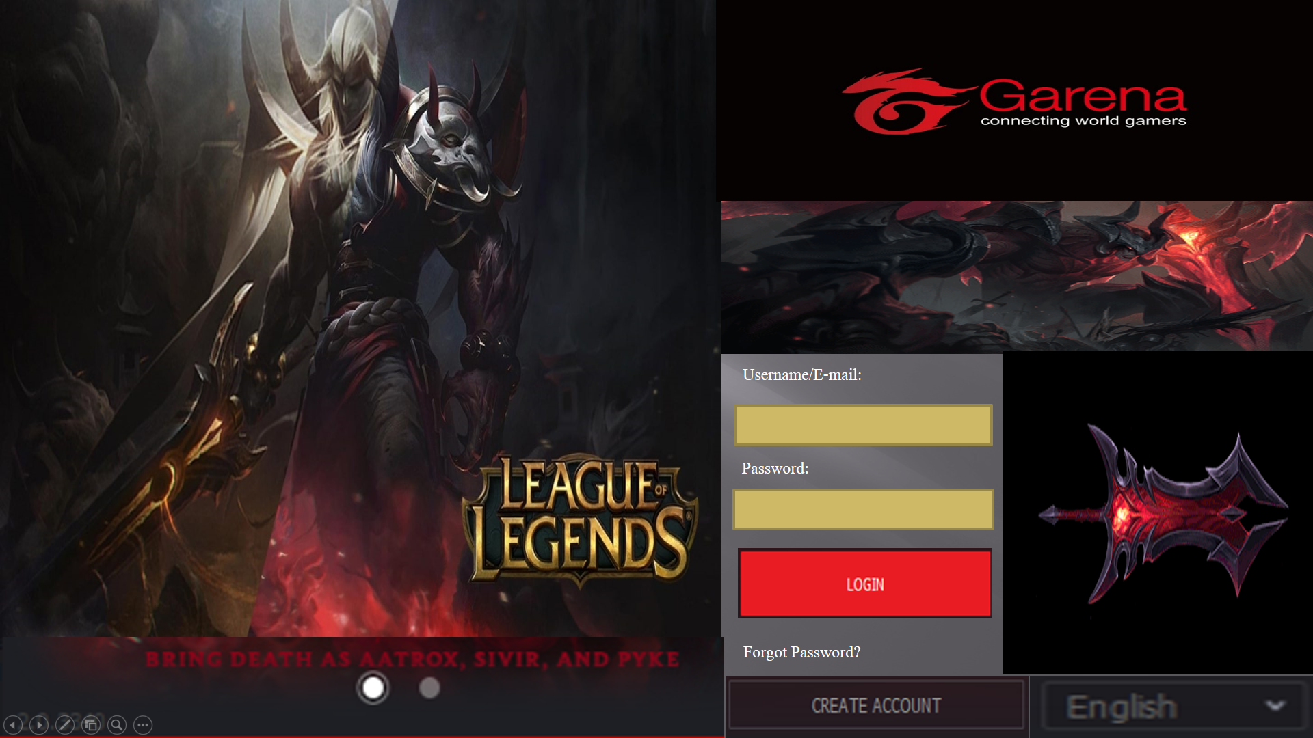

HOME/LOADING SCREEN

